Mara Levine releases a new video for uplifting bluegrass single "You Reap What You Sow"

I'd like the video link to be at the top of the announcement please!

View video here: https://youtu.be/1qQ0mR4Smu8

Song bio
Written by Susan B. Shann, Mystics Mantra Music, ASCAP
Produced by Mara Levine and Bob Harris at Ampersand Records
Bell Buckle Records re-release
Lead Vocals: Mara Levine
Harmony Vocals: Mollie O'Brien(Courtesy of Remington Road Records) and Greg Blake
Guitar: Bob Harris
Bass: Mark Schatz
Banjo: Scott Vestal
Mandolin: Andy Leftwich
Dobro: Rob Ickes

Radio Programmers can download the track for airplay here: http://www.airplaydirect.com/music/maralevine/
or
https://bellbucklemedia.com/mara-levine-press

Photo by Manny Krevat

Artist and Song Information
Called one of the best singers of her generation by Christine Lavin, and hailed as “the new standard-bearer for folk music” by the Midwest Record, New Jersey based songbird Mara Levine releases her new socially distant video "You Reap What You Sow" just in time for the Fall harvest and the Thanksgiving holiday.

The video was featured by John Lawless in Bluegrass Today on October 30.
https://bluegrasstoday.com/video-premiere-you-reap-what-you-sow-from-mara-levine/

Recorded with a stellar cast of bluegrass musicians, this inspirational track from Levine’s top-charting album Facets Of Folk, which hit #1 on the FAI Folk DJ chart and spent 22 weeks on the Bluegrass Today Grassicana chart, is being re-released on Bell Buckle Records.
Levine said "The entire song resonated with me as a positive message about doing your best at whatever you do and reaping the rewards or fruits of your labors. One could also interpret the song to mean caring for others and nurturing relationships, in particular keeping your word and your commitments and that this will be returned to you in kind. I hope that folks watching the video come away feeling positive, uplifted and inspired"
The video was produced and directed by Valerie Smith, who shot footage at The Sunflower Garden, Westminster, MD https://www.thesunflowergarden.com/, and the guest artists shot socially distant footage of themselves during the pandemic from their homes.

In conjunction with Bell Buckle Records re-release, Les Butler, of Butler Music Group and Family Music Group, will be sending "You Reap What You Sow" to Southern Gospel and Bluegrass Gospel radio programmers for January 2021. Butler was impressed by the song and recording upon first listen and said "This song and this voice was a breath of fresh air the moment I heard "You Reap What You Sow." I am honored to represent Mara and this song as a single to Gospel radio worldwide!"

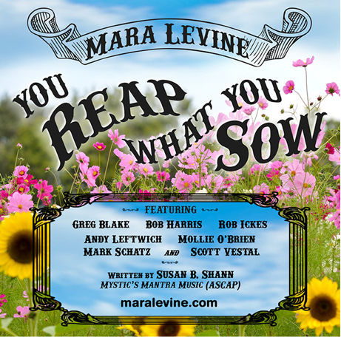
The track can be purchased via download here: https://maralevine.com/music

"Mara Levine is a gifted singer whose expressive and versatile voice is suited to any style of music she darn well pleases to focus on, including bluegrass, country, or folk."
- Dede Wyland, SKYLINE

“Mara Levine’s clear and expressive vocal on “You Reap What You Sow” is supported by a stellar lineup of musicians who together deliver a tasteful and artfully produced rendition of this heartwarming song.”
~Mark Schatz

FOLLOW MARA LEVINE
www.maralevine.com
Facebook https://www.facebook.com/mara.levine1
Twitter https://twitter.com/marablevine1
SOUNDCLOUD: https://soundcloud.com/mara-b-levine/tracks
You Tube Standard License , Licensed To YouTube By: Mara Levine (Mara Levine has obtained a sync license from Susan B Shann, Mystics Mantra Music, ASCAP. License available on request.

