December 11, 2020

Crandall Creek releases Headed South

Tales of lost love, love of family and love of God are on Crandall Creek’s newest album, Headed South. The 11-song CD showcases the West Virginia-based band’s talent for telling Appalachian stories through bluegrass songs.
“The album has been a while coming,” says Crandall Creek founder Jerry Andrews. “But I’m really excited about each and every song.”
The album is a labor of love for Kathy Wigman Lesnock, who sings and writes for the band.
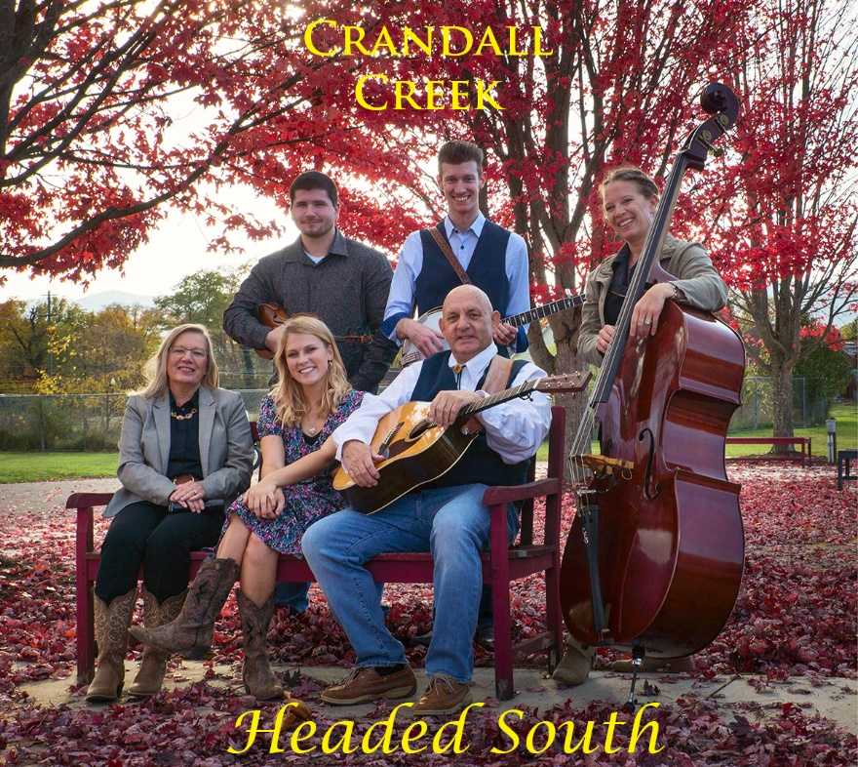
“We have all worked incredibly hard to see this project come to fruition,” Kathy says. “I am grateful to every person seen and unseen who had a hand in this project. And I am filled with love for our entire band family.”
Crandall Creek records for Bell Buckle Records and is based Moundsville, West Virginia. Several songs from Headed South made the bluegrass charts earlier in 2020.
Drivin’ Me Insane was released in March and stayed on the charts for more than six months. This Heart of Mine debuted at No. 1 in May. The Bean Song was released in the fall. By November The Bean Song and Drivin’ Me Insane were in the top 10 of the Bluegrass Today chart. The singles also appeared on The Bluegrass Jamboree chart.
Jerry founded Crandall Creek in 2015. He plays rhythm guitar, sings and is joined by:
- Kathy, lead and harmony vocals.
- Dustin Terpenning, banjo, mandolin and guitar.
- Abby Latocha, lead and harmony vocals.
- Trish Imbrogno, upright bass.
- Wyatt Kidd, fiddle.
- Roger Hoard of Wheeling, West Virginia, guest lead guitarist.
- Other guest musicians are Aaron Till, fiddle and mandolin; and Jamie Peck, bass.
While Jerry and Kathy are principal songwriters, Abby, Dustin, other band members and even family collaborate on the songs. The result is original bluegrass and gospel true to the band’s Appalachian roots.
Valerie Smith of Bell Buckle Records is the executive producer of the band. Jamie Peck of Jamie Peck Productions in Wheeling records and produces Crandall Creek. Mastering is by JP McMullen III of Highland Mastering in Pittsburgh, Pennsylvania. Bruce Winges of Cuyahoga Falls, Ohio, handles the band’s publicity and media.
Crandall Creek also donates to deserving charities through the Bluegrass Music Endeavors Foundation, a non-profit 501c3 set up by Jerry.
To download the Headed South album, go to crandallcreekband.com, Bell Buckle Records, Amazon or Spotify. If you want a physical copy of the CD, call 330-281-5776 or email Jskve@aol.com.
We hope you enjoy listening to the music as much as we enjoyed creating it.

Valerie Smith
Bell Buckle Records/Media
PO Box 142
Bell Buckle, TN 37020
bellbucklerecords@gmail.com

