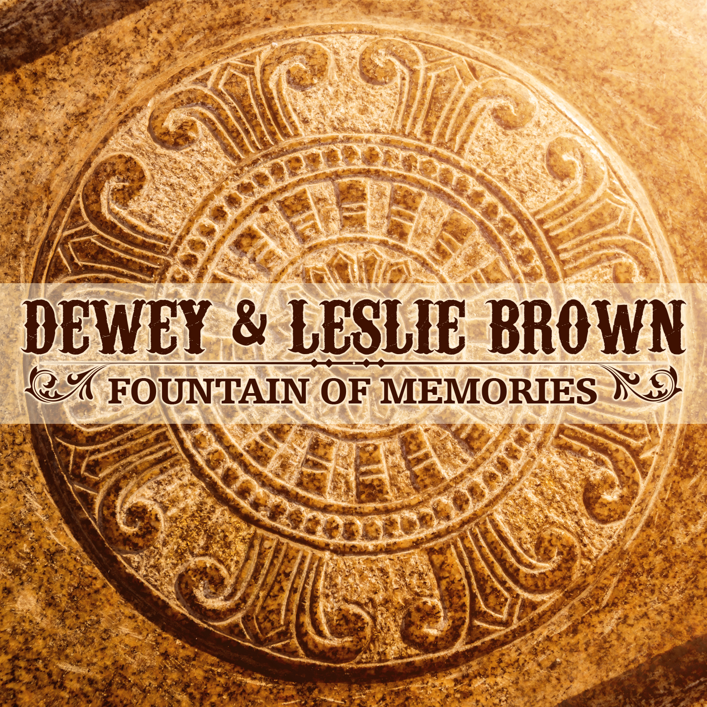
AVAILABLE FOR RADIO AIRPLAY
DEWEY AND LESLIE BROWN
WRITTEN BY LESLIE BROWN AND DEWEY BROWN
Liberty Showcase Publishing
ISRC: TCAFK2153946
STREET DATE: MARCH 26, 2021
WWW.DEWEYANDLESLIEBROWN.COM
BELL BUCKLE RECORDS

Leslie Brown- Bass and Lead Vocals|
Dewey Brown-Fiddle and Harmony Vocals | Kendall Gales- Mandolin | Brandon Hinson- Banjo | Tim Spence- Guitar | Produced by Dewey and Leslie Brown

Leslie and Dewey Brown offer up a powerful performance with their original song "Fountain of Memories." The song is a true story about Leslie's coal-mining family from the mountains of Vansant, Virginia. The story unfolds as a tale about greed, love lost, and family relationships forever fractured over money and land. Dewey Brown provides a pure and authentic, rich and soulful fiddle in a style that is all his own. The harmonies and arrangements are a true reflection of raw, beautiful mountain styles that can only be created from the heart. This is a rare and special recording which will leave an impressive lasting impression on the music community. A lyric video will also draw you into this tale of warnings about the unfortunate fruits of greed.

Burlington, North Carolina's Dewey, and Leslie Brown are a power couple with bluegrass talent who bring together Ralph Stanley's sounds mixed with Hazel Dickens. Dewey played fiddle as a Clinch Mountain Boy for Dr. Stanley for 11 years, until he died in 2016. Moreover, Dewey released CD, "Traditional Fiddle," featuring Ralph Stanley and The Clinch Mountain Boys. Leslie is an authentic coal miner's daughter raised by her grandparents in the Appalachian Mountains of Vansant, Virginia. Her upbringing in those mountains has played a significant role in her songwriting, dancing, and singing. Leslie is about the most authentic mountain girl you will ever meet. Together, their music is powerful and genuine to bluegrass tradition. Dewey and Leslie currently own The Reidsville Showcase Theater in Reidsville, North Carolina. They also run two festivals, "Deweyfest" and "Gospelfest." They are releasing a new CD called "Jealousy" with their band, The Carolina Gentlemen, this coming Spring 2021.
PO Box 142 * Bell Buckle , TN 37020 * 931-639-3004
bellbucklerecords@gmail.com
www.BellBuckleRecords.Com

